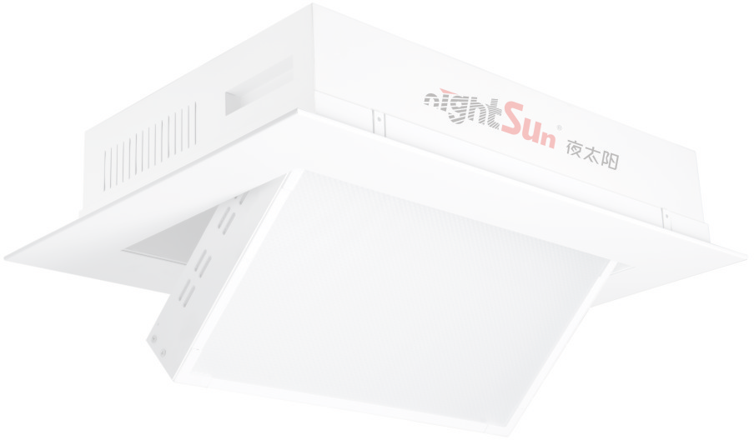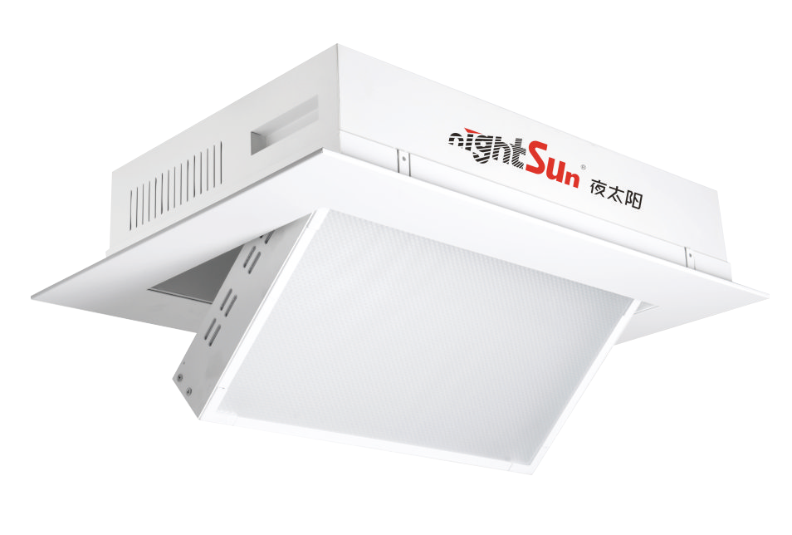
GPS007N
Power supply: AC100~240V/50~60Hz
Power consumption: 200W
Electric Flip Embedded Panel LED Tri-Color
Light source: 806pcs Taiwan Addison 0.5W high-display high-brightness LED patch beads

operation
Control channel: 2CH
Display:LCD display screen + dot matrix button operation, the interface operation is faster and more convenient.
Flip Angle: electric adjust ﬂip 0 ~ 65°

Optical system
Color rendering index: CRI ≥ 95 Beam Angle: 120°
Color temperature: 3200K/5600K optional Center illumination: ≥644Lux/ 3meters; Focusing:
Electric, aside from the wire rope focusing method on the market,
this product uses electric motor to transmit
Flip the belt to focus, so that the lamp in the ﬂip, smoother, faster, more stable!
Dimming:DMX512 dimming mode, independent electronic linear dimming, up to 65535 bit curve dimming mode, so that during the dimming process, no ﬂicker, jitter, jump, dimming color change is softer, the camera is clearer and more realistic.

Speciﬁcations
Working environment: IP20/ indoor use Working environment temperature: -20°C~40°C Product size: 610×390×125MM
Opening size: 590×355mm Weight: 12 kg

NIGHTSUN PROFESSIONAL LIGHTING PROVIDER.

