

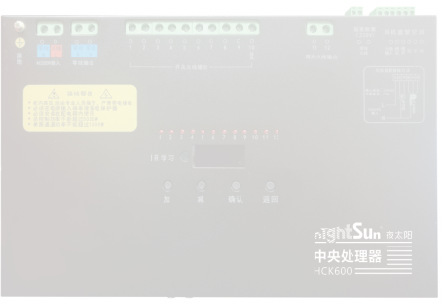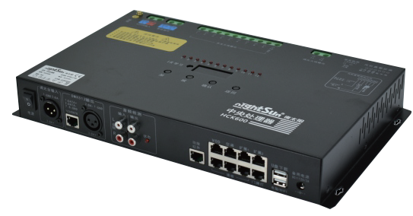

**HCK600CPU**

Power Supper：AC～220V/50-60HZ

Power Consumption：5000W，Resistive load

Backup Power: DC 12V/1A for easy debugging

External Power Supply: DC12V/1A power supply is provided through

RJ45 port, including wall panel, house number lamp, expansion 1/2,junction box Machine power consumption：≤12W

Power Switch: When OFF is turned oﬀ, the relay open circuit has no

220V output, which is safe and convenient to maintain.

Dimmer Input: cannon*1, input the DMX512 signal of the dimming

station, and the recording well can be edited again to complete more applications. DMX512 output：Cannon *1，RJ451，512 channels

Audio Detection: RCA*2 input, RCA*2 loop output

Ampliﬁer Infrared: RJ45 interface, providing dedicated infrared emitter, network cable connection

VOD: RJ45 interface, connected to karaoke machine through the junction box Air Conditioning: connecting wiring to achieve infrared and RS485

control air conditioning

Wall panel door light: RJ45 interface, RS485 communication, using RS485 bus control protocol

Extended 1/2: RJ45 interface, RS485 communication, reserved other extended applications.IR receiving window; built-in infrared receiver to learn infrared code value

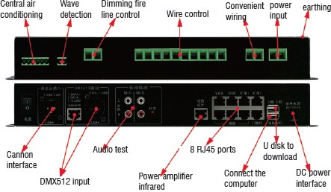USB FLASH DISK Download: Upgrade the program via USB FLASH DISK, download parameters, update the wiring program Computer / WIFI: USB FLASH DISK port, external WIFI module accessories, eﬀect debugging, download wireless completion, support wired mode

Button Display: 4-digit button and 4-digit digital tube as function settings and status display

LED Display: Corresponding to the status display of 12 control channels, the corresponding LED is bright when connected Net Weight: 2.16kg

Installation Method: Wall mounting DimensionSize: L355×W220xH46mm

NIGHTSUN PROFESSIONAL LIGHTING PROVIDER.