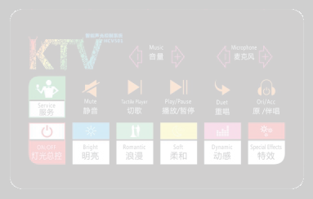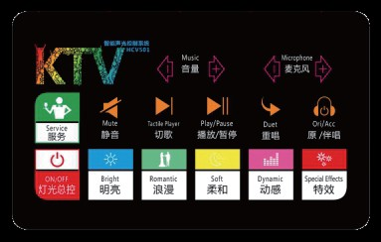
HCV501
Service Intelligence Board
(Horizontal Screen)

Dimensions Size：190(L）*118(W)*10(D)mm
Touch Mode: Capacitive
Backlight: Overall backlight Number of Buttons: 18
Panel Material: Tempered glass Frame Material: Zinc alloy
Net Weight: 0.5KG
Installation Method: Standard 86 bottom box

NIGHTSUN PROFESSIONAL LIGHTING PROVIDER.

