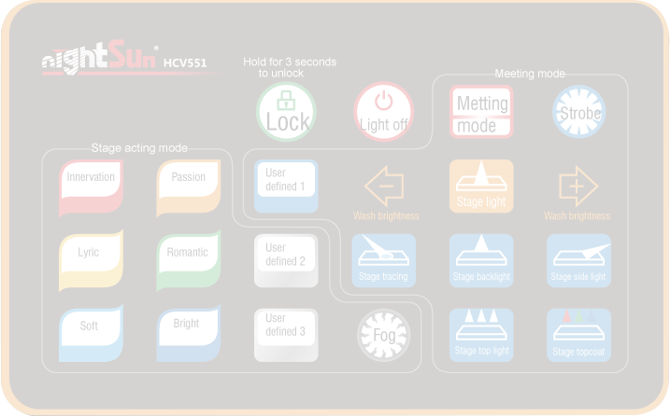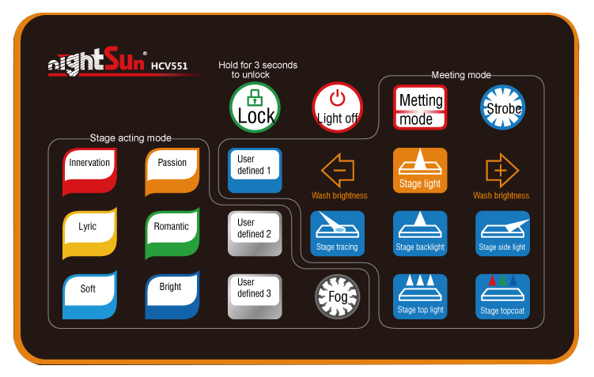
HCV551
Intelligen Walkboard

The wall function is to realize the intuitive user control, installed
on the wall,use a network cable and HCK800 central processing unit (CPU) connection.
HCK800 CPU through the Ethernet cable to the button of the power supply and receive wallboard wall panel control command.
Wall panel contains 22 function keys, the convenient user a key control, wallboard has locking function to prevent wrong operation.

The wiring way: RJ45 cable (568 b)
POE power supply: DC12V power supply The method of touch: capacitor
The number of keys: 24
Installation: standard 86 bottom box

NIGHTSUN PROFESSIONAL LIGHTING PROVIDER.

