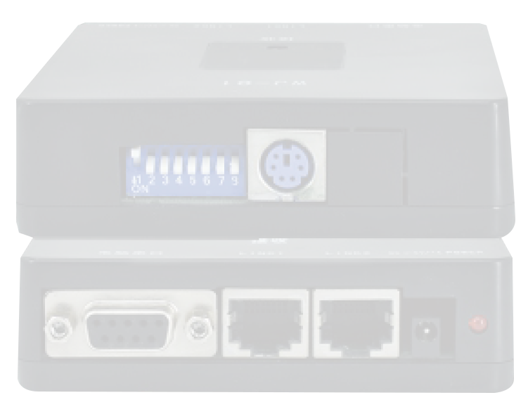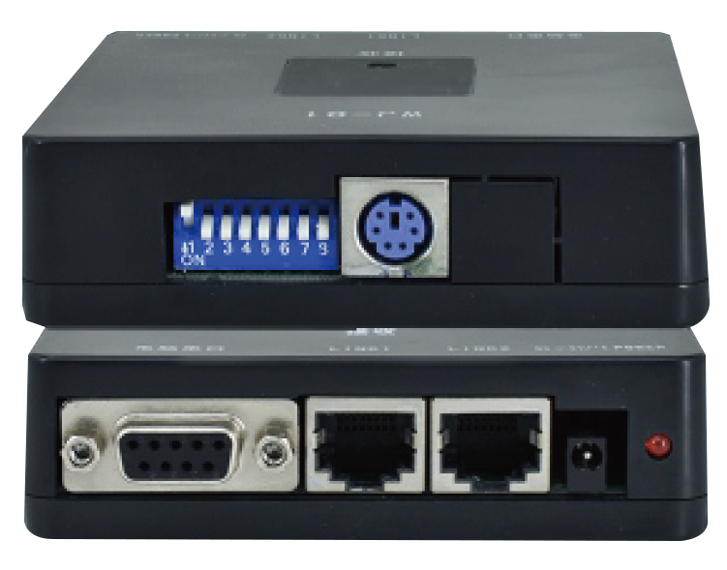
HCV556
Single Receiver Of Mobile
Intelligent Console

Products matching by dial the code switch,Mobile intelligence controller address is the same as the receiver address pairs can be realized, only need to install a recei.

NIGHTSUN PROFESSIONAL LIGHTING PROVIDER.

