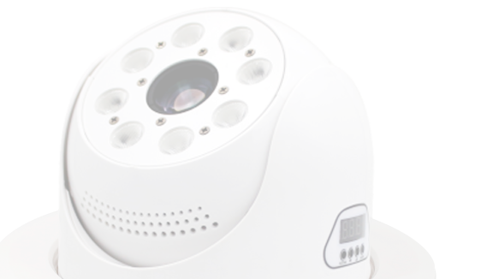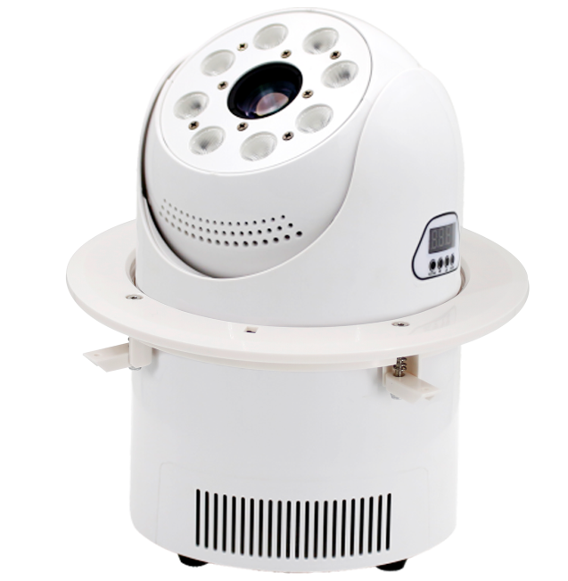Light Source : 8 X 8W RGBW 4 IN 1 LED

HSA716 LED Moving Head Wash + Pattern
Power Supply : AC100-240V , 50Hz-60Hz
+1 X 60W White LED
Power Consumption : 108W
Controls : DMX512 ,Sound activation ,Auto, Master / slave
DMX Channels: 19 Channels Life time : 60000 hours Color wheel: 7 color + white
Gobo wheel: 7 gobos + white
Prism: 3 facet prism can be rotated forward and
reverse
Flas: Flash speed up to 10 times/sec
Pan / Tilt rotation : 540° / 150° rotate speed can be adjusted Wash angle: 40°
Spot angle: 18°
Spot color temperature (white): 7500K Control panel: 4 LCD tube + 4 press bottom DMX connector: 2×Rj45 input and output or 2×XLR input and output optional
Dimmer: 0-100% linearly adjustable
Protection rate : IP20
Working environment : up to 40°C
Material : ﬁre-proof ABS plastic, White housing. Dimension size : φ176×248mm
Packing size: 270×270×350mm / 540×540×420mm (4pcs/ctn) N.W: 3.5kg
G.W: 4.3kg /19.2kg (4pcs/ctn)

NIGHTSUN PROFESSIONAL LIGHTING PROVIDER.

