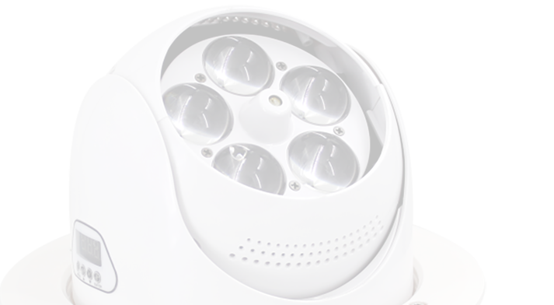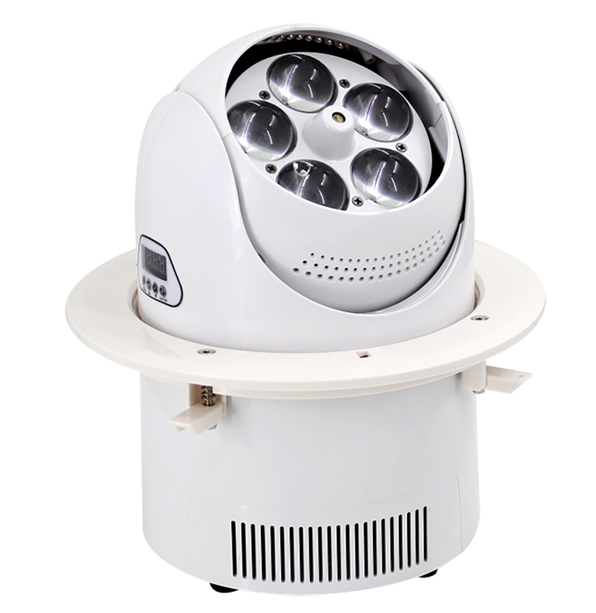
HSA731
LED Moving Head Zoom + Wash

Power Supply: AC100-240V,50Hz-60Hz Light S ource: 5 X 15W RGBW 4 in 1 LED Power Consumption: 70W
Controls: DMX512,Sound activation,Auto, Master / slave
DMX Channels: 14 Channels Life time: 60000 hours Beam angle: 9-55°
Strobe: Strobe speed up to 20 times/sec
Pan / Tilt rotation: 540° / 150° rotate speed can be adjusted Control panel: 4 LCD tube + 4 press bottom
DMX connector: 2×Rj45 input and output; 2×XLR input and output (optional) Dimmer: 0-100% linearly adjustable Protection rate : IP20
Working environment : up to 40°C
Material : ﬁre-proof ABS plastic, White housing. Dimension size: φ176×248mm
Packing side: 270×270×350mm 540×540×420mm(4pcs/ctn) N.W: 3.2kg
G.W: 4kg/18kg (4pcs/ctn)

NIGHTSUN PROFESSIONAL LIGHTING PROVIDER.

