Power Supply: AC110-240V,50Hz-60Hz Light Source: 80W
Power Consumption: 218W DMX Channels: 16 Channel Pan rotation: 540°
Tilt rotation: 270°
Zoom: electronic zoom in and zoom out Display: LCD
Color temperature: 8500K Electricalsafety level : Class I Life time : >20,000 hours Power factor: >0.93
Dimmer: 0-100% linearly adjustable
ESD protection : IEC61000-4
Controls: Auto, master-slave, DMX512, RDM, scene DMX connector: 2 × Rj45 (input and output);
2 × XLR (input and output)
Color system: a seven-colors wheel and a color
wheel,13 colors + white light
Gobo wheel: 1 ﬁxed gobo wheel (gobo optional)
+ white light, positive and negative rotation+shake Prism: an 8 prism, a 16 prism, can change speed, clockwise and counterclockwise rotation,
double prism stack.
Prism rotation: can change speed, clockwise and counterclockwise rotation
Power output: 200W, two outputs, 28V/7A, 14V/3A Working temperature : -25°C-50°C
Protectionrate: IP25Temperature control system: intelligent temperature control system,monitoring andautomatic regulation of temperature
Housing material: high-strength steel + anti-UV coating Dimension size: 274 × 487mm
Holesize: 350mm standard circle, ceiling reserved
height:200mm
Packing size: 350 × 320 × 370mm N.W: 14.5kg
G.W: 15.5kg

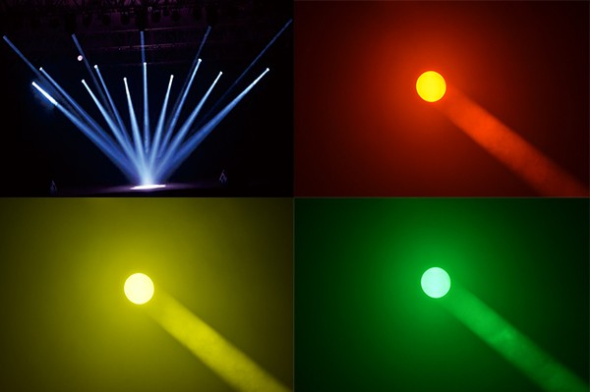

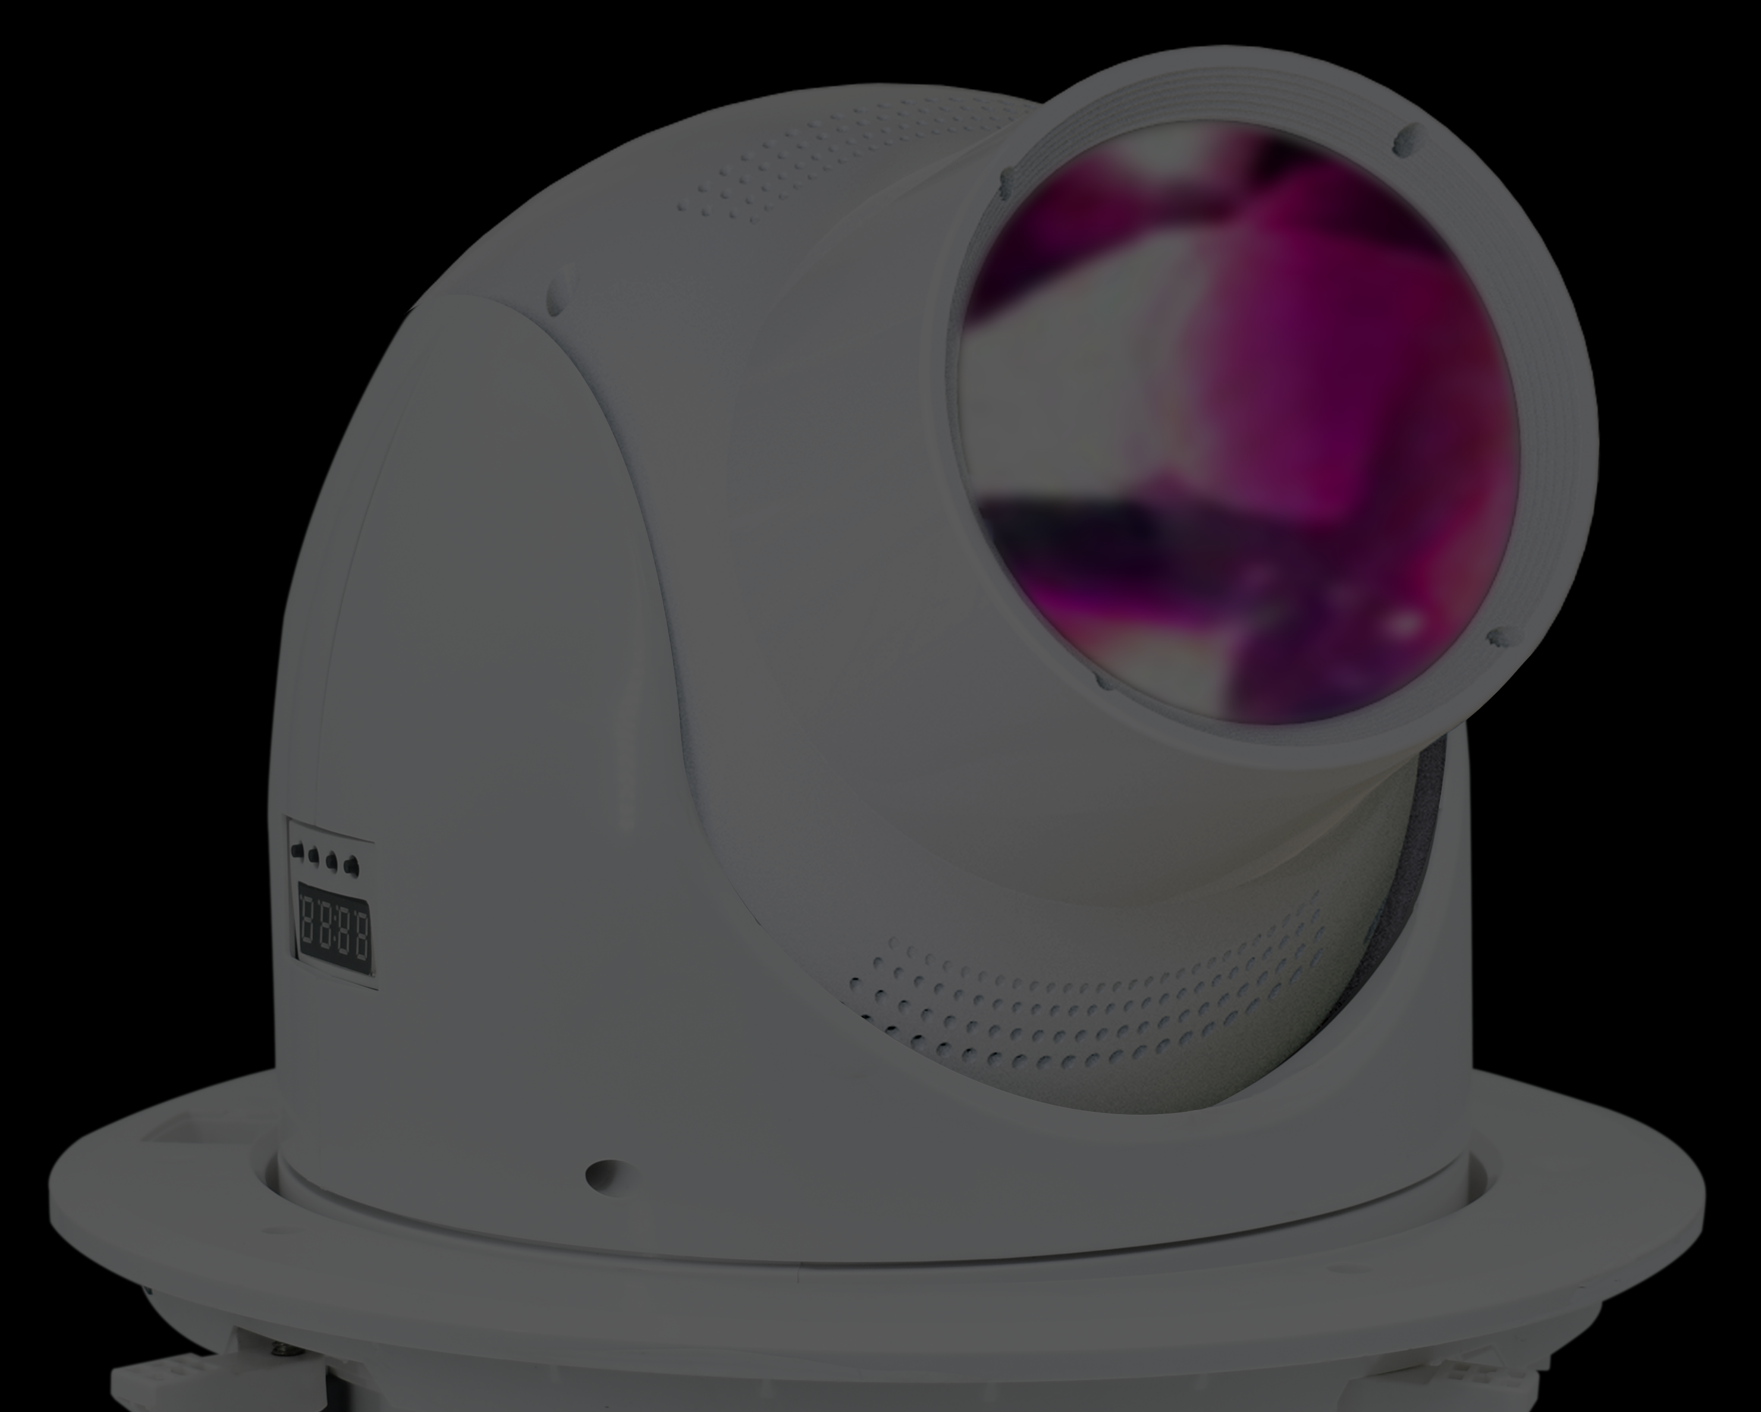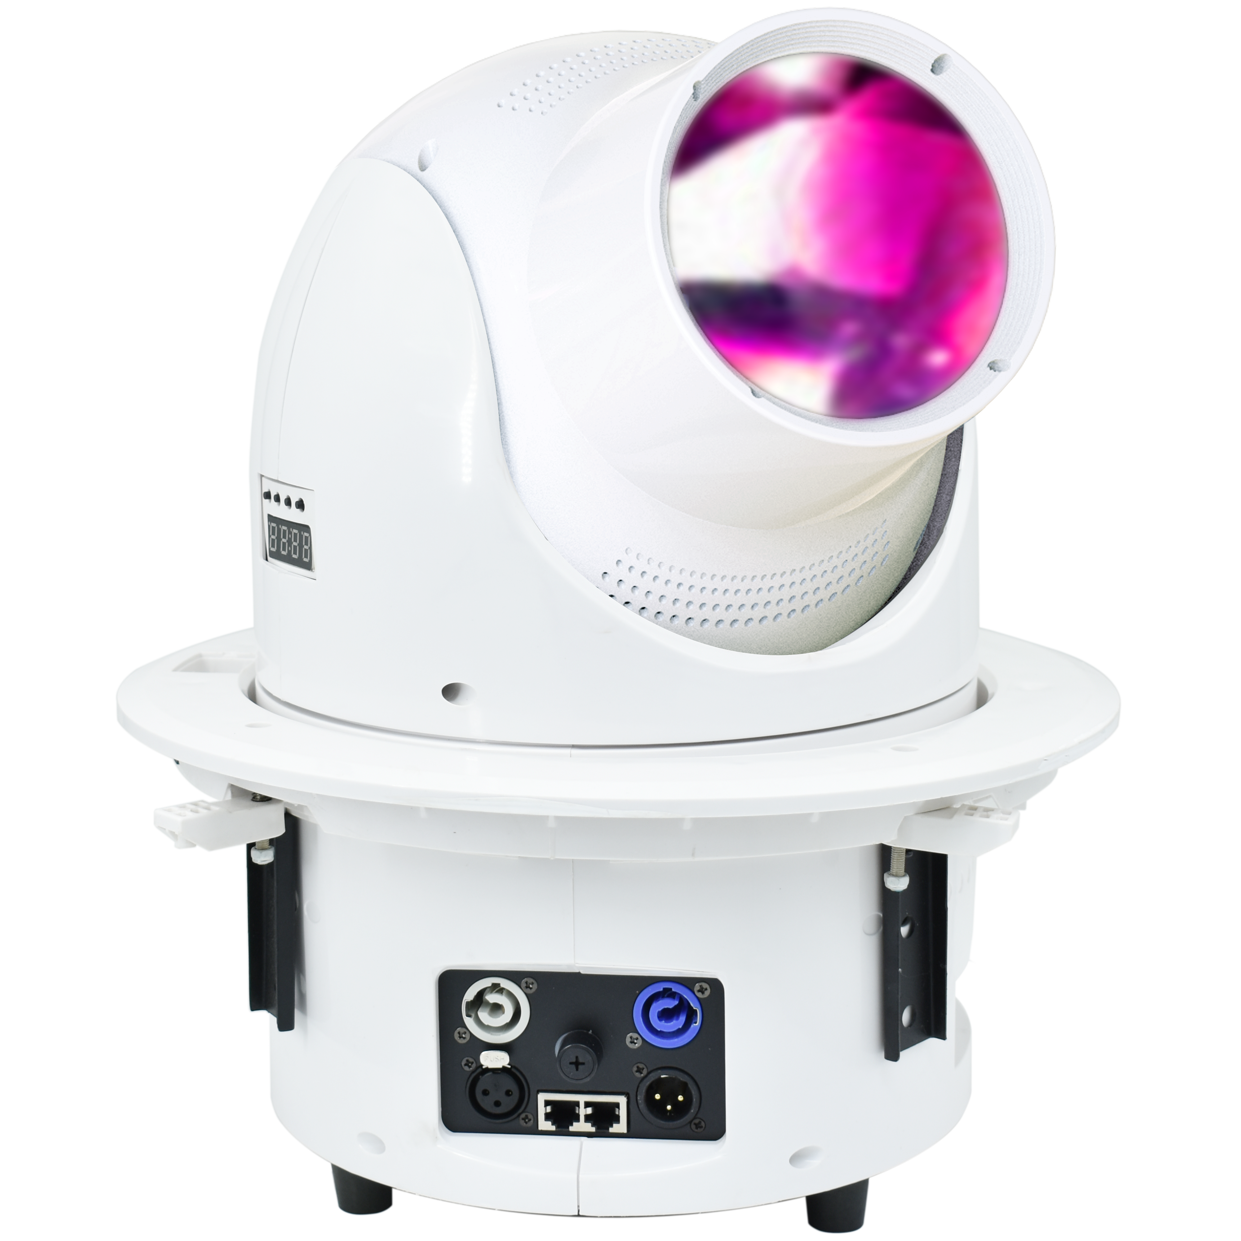
HSA917
LED Moving Head Beam

NIGHTSUN PROFESSIONAL LIGHTING PROVIDER.

