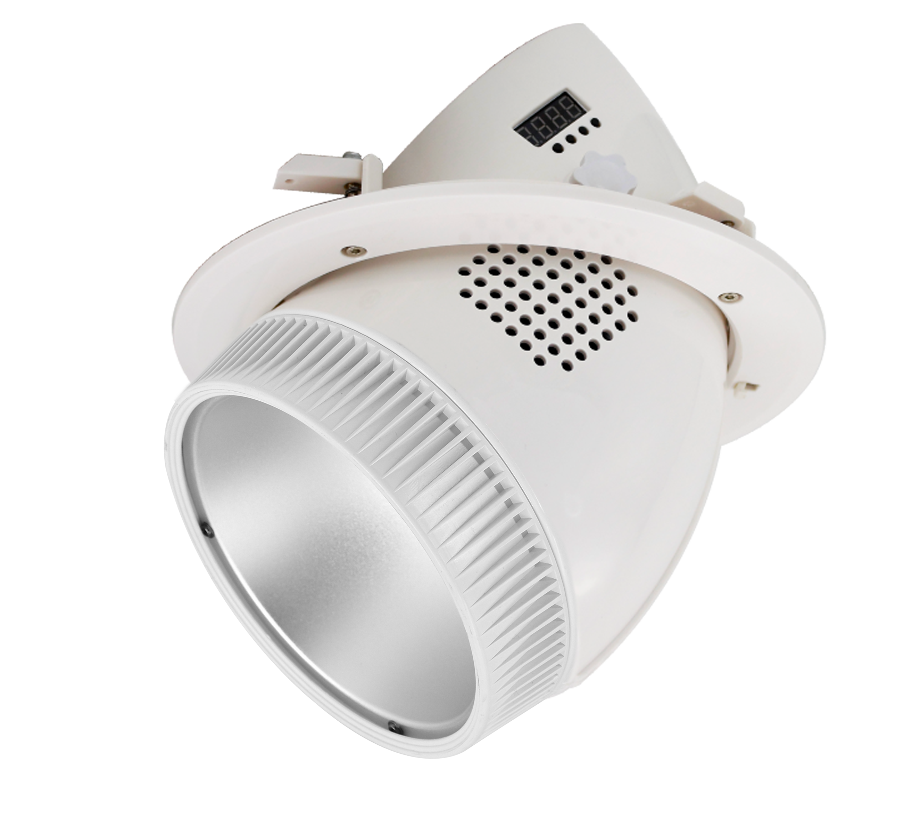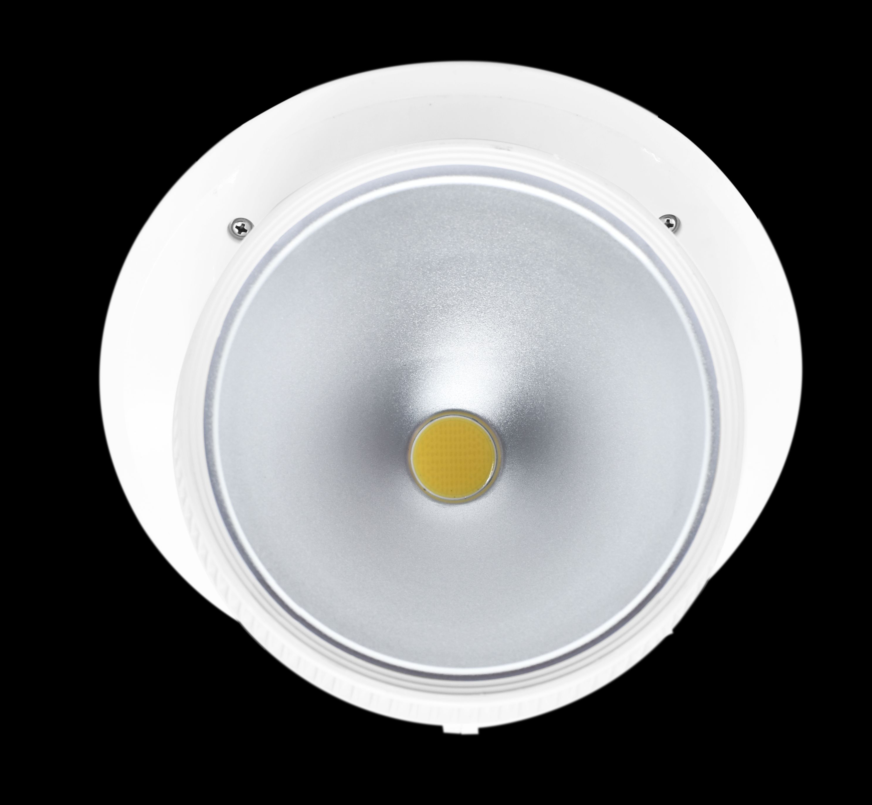
HSB713
Embedded COB PAR Lights
HSB713 is a high brightness COB PAR lights with built-in temperature control for meeting.

In a silent state. Wide angle adjustment design of 0-85 degree can be adjusted ﬂexibly according to site requirements.
Outlet, to meet the diﬀerent angles of light rendering eﬀect.

Power Supply: AC100-240V;50Hz-60Hz
Light Source: 36 X 3W high brightness LED(24 X 3200K warm white LED ;12 X 5600K cool white LED)
Light Source: 90W
Controls: DMX512,Sound activation,Auto
DMX Channels: 5/8 Channels
Life time: 60000 hours Bean angle: 25/45° optional
Strobe: Strobe speed up to 20 times/sec
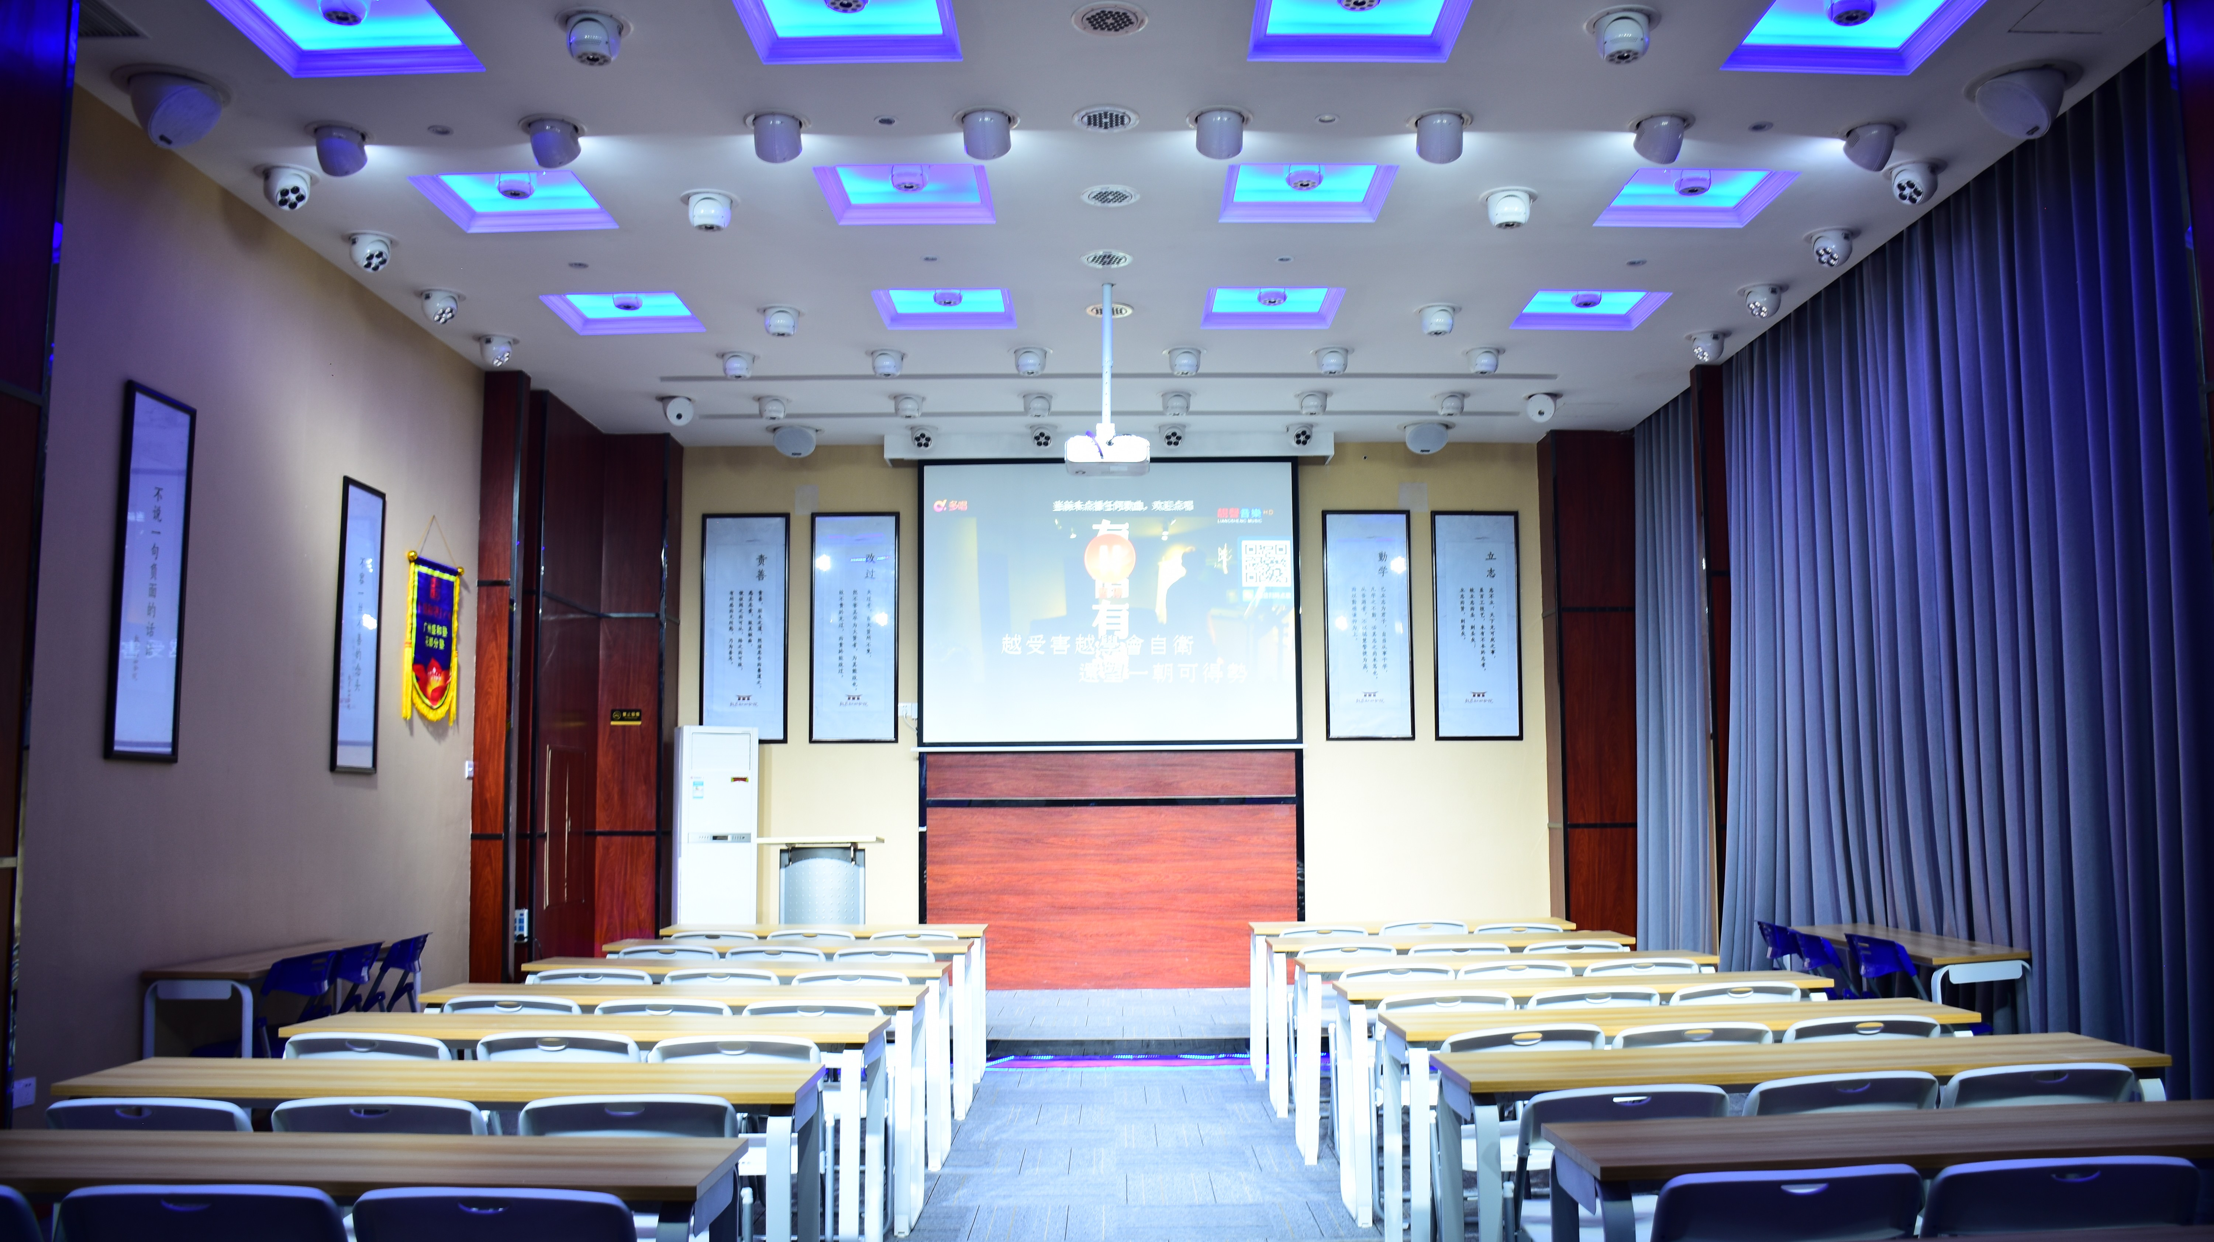
Pan / Tilt rotation : 540° / 150°,rotate speed can be adjusted Control panel: 4 LCD tube + 4 press bottom
DMX connector: 2×Rj45,input and output;
2×XLR,input and output
Dimmer: 0-100% linearly adjustable Protection rate: IP20
Working environment: up to 40°C
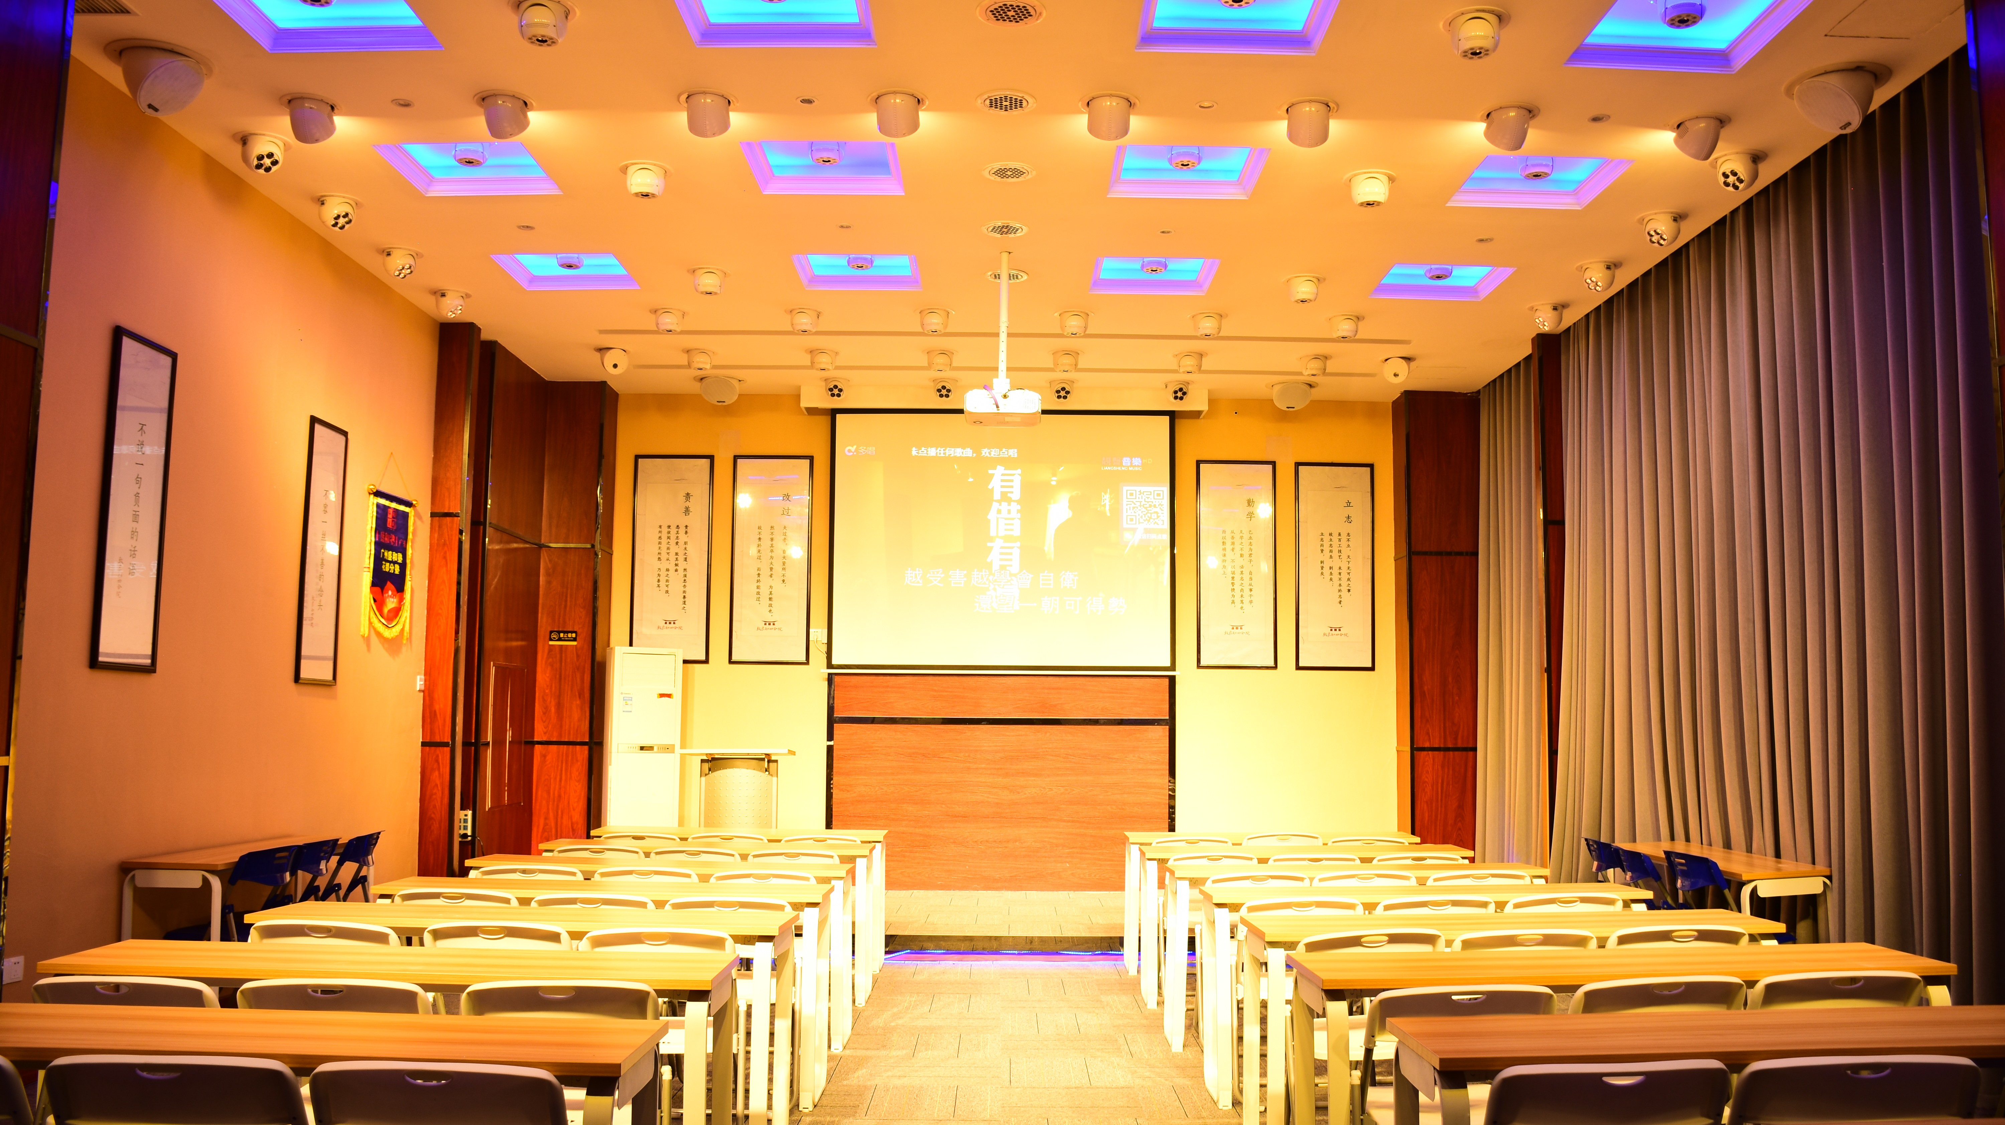
Material : ﬁre-proof ABS plastic, White housing.
Dimension size : 187×170×197mm Packing side: 270×270×280mm 560×560×305mm(4pcs/ctn)
N.W: 1.5kg
G.W: 2.3kg/11.2kg (4pcs/ctn)

NIGHT SUN PROFESSIONAL LIGHTING PROVIDER.

