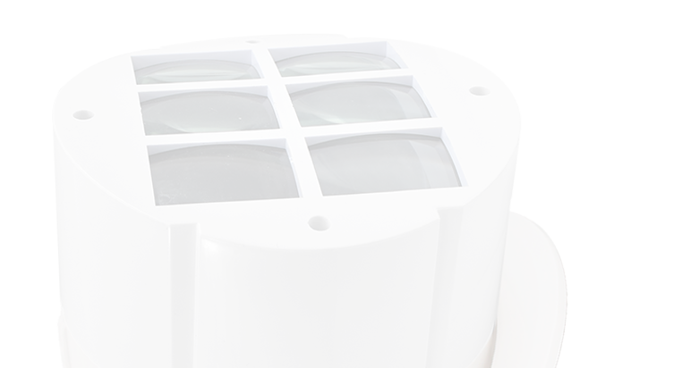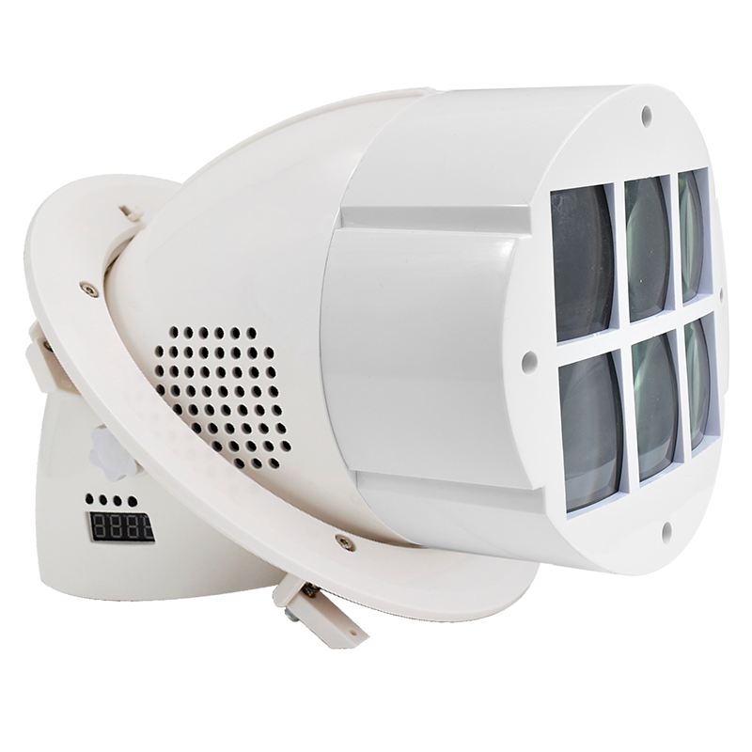
HSB750
LED Magic Beam light
Power Supply: AC100-240V;50Hz-60Hz
Light Source: 2x15W RGBW( 4 in 1) Tianxin LED

Power Consumption: 35W
Controls: DMX512;Sound activation,Auto,Master/slave
DMX Channels: 10 Channels
Life time: 60000 hours
Flash: Flash speed up to 20 times/sec Control panel: 4 LCD tube + 4 press bottom DMX connector: 2×Rj45 input and output; 2×XLR input and output
Dimmer: 0-100% linearly adjustable
Protection rate: IP20
Working environment: up to 40°C
Material: ﬁre-proof ABS plastic, White housing.
Dimension size: 187×170x276mm Packing size: 270×270×350mm 560×560×385mm (4pcs/ctn) N.W: 1.5kg
G.W: 2.2kg /11.2kg (4pcs/ctn)

NIGHTSUN PROFESSIONAL LIGHTING PROVIDER.

