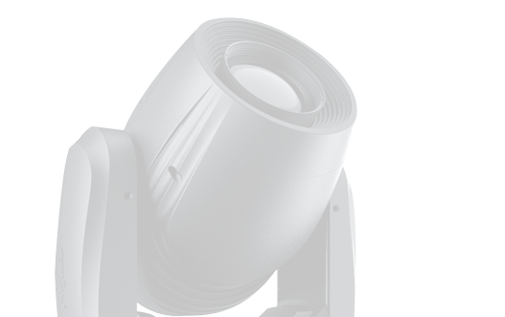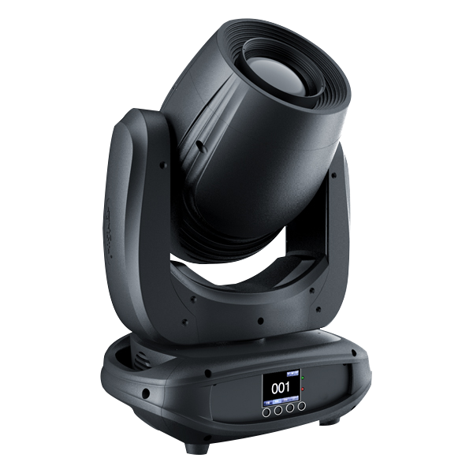
KBL180B
Saber Beam
Power supply: AC 100V-240V, 50/60Hz

Power consumption: 260W Light source: 180W White LED Life Time: 50000 hours
Color temperature: 6000-8000K Beam angle: 6°
Control panel: LCD display
Controls: sound activation, auto, master/slave,DMX512 DMX channels: 13 / 16CH channels mode
Pan/Tilt rotation: 540°/ 270° Color : 7colors+white
Gobo wheel 1: 8 Gobos + open
Rotation Gobo wheel 2: 6 Gobos + open
Prism:8-facet prism
Focus: Electronic linear focus
Dimmer: 0-100% with regulated constant color control Strobe: electronic strobe with pulse and random eﬀects, 10Flashes per second.
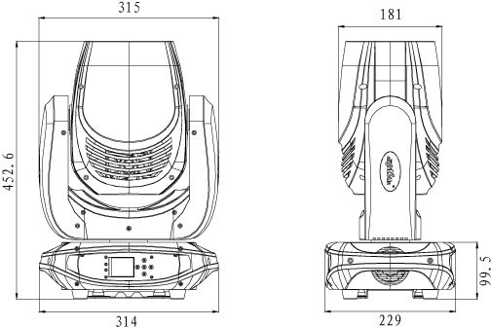
Working environment: up to 40°C Protection rate: IP20
Cover: plastic
Dimension size: 280×270×470mm Packing size: 370×290×520mm N.W: 10.6 kg
G.W: 12.6 kg

NIGHTSUN PROFESSIONAL LIGHTING PROVIDER.

